Written Assignment Unit 1
Wireshark after relaunch
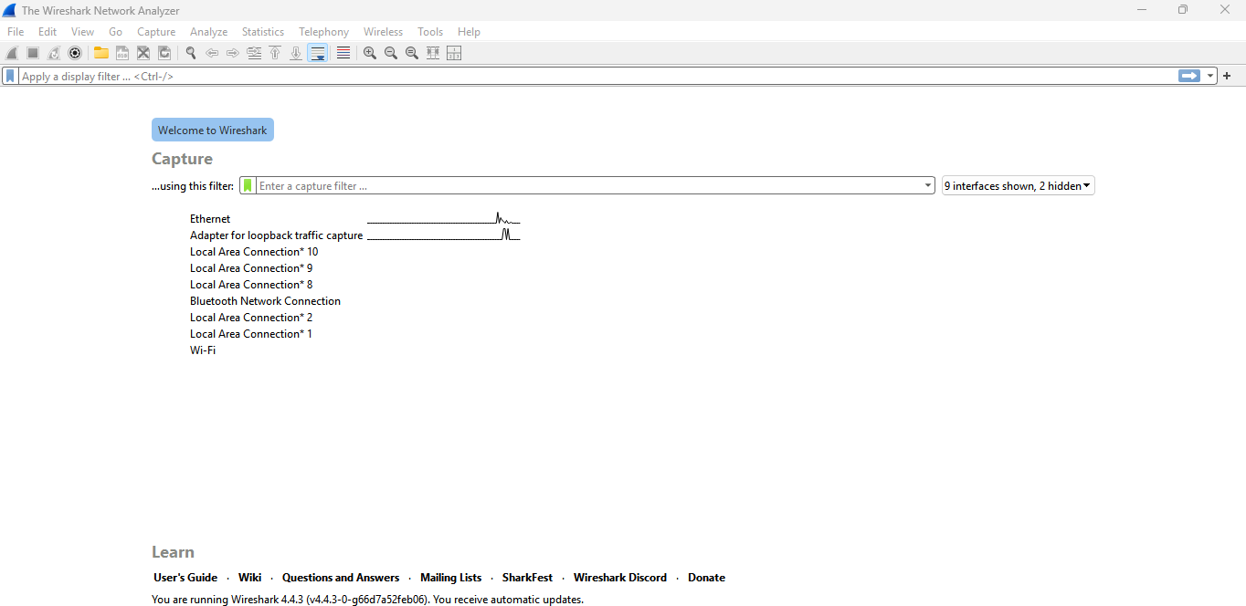
Wireshark activity after opening the “Course Forum” and “Announcement Forum” from UoPeople student portal.
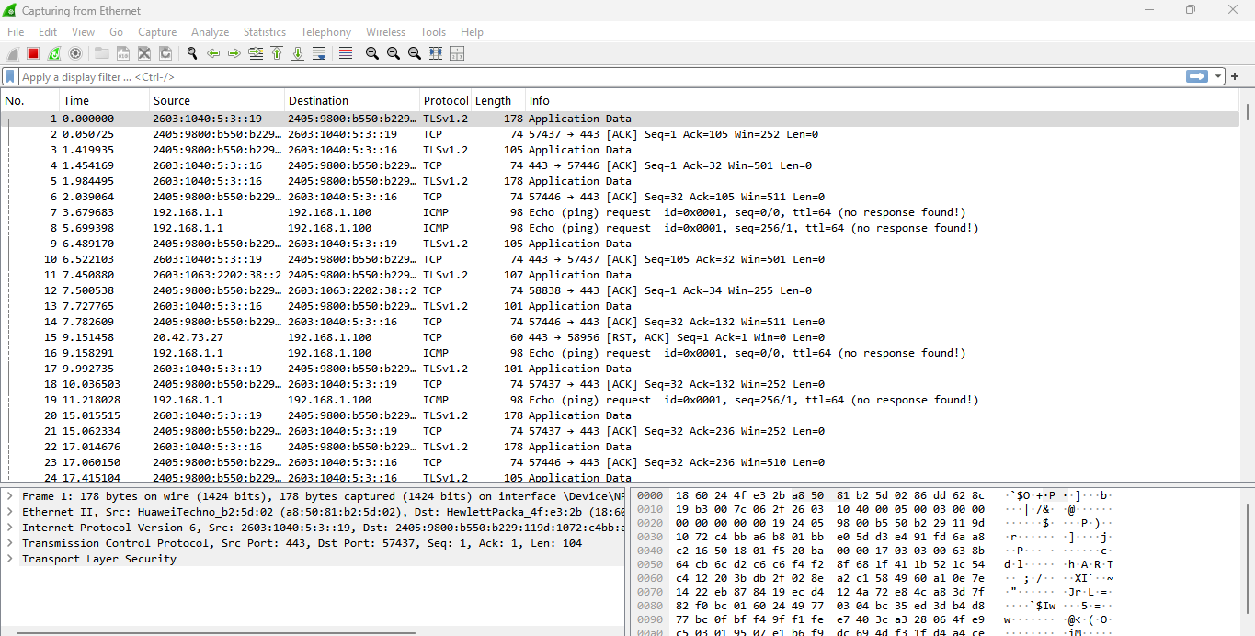
Wireshark 30 seconds after opening the browser
